**Created 3 new fields in Sales Line:**

They have data type Code and Length of 20

1. Tire Size
2. Speed Rating
3. Season Designation

Open Sales Order

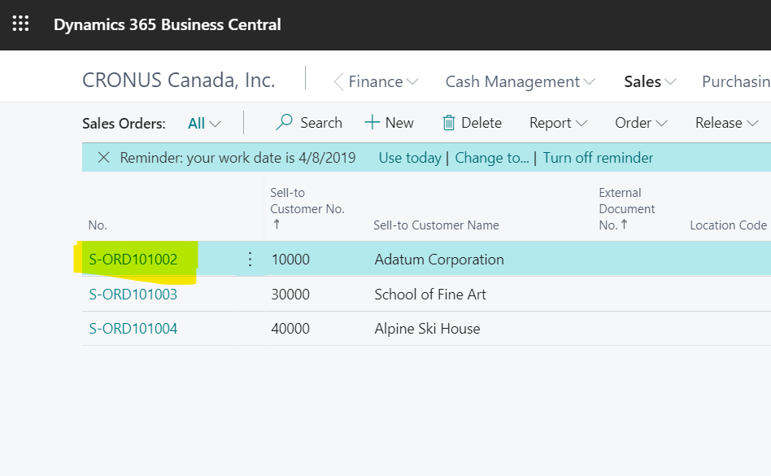

In Sales Order Card go to the Sales line, select the first line and scroll right. After “Qty. to Assign”, you will find these 3 fields. Input Test Data in these three fields.

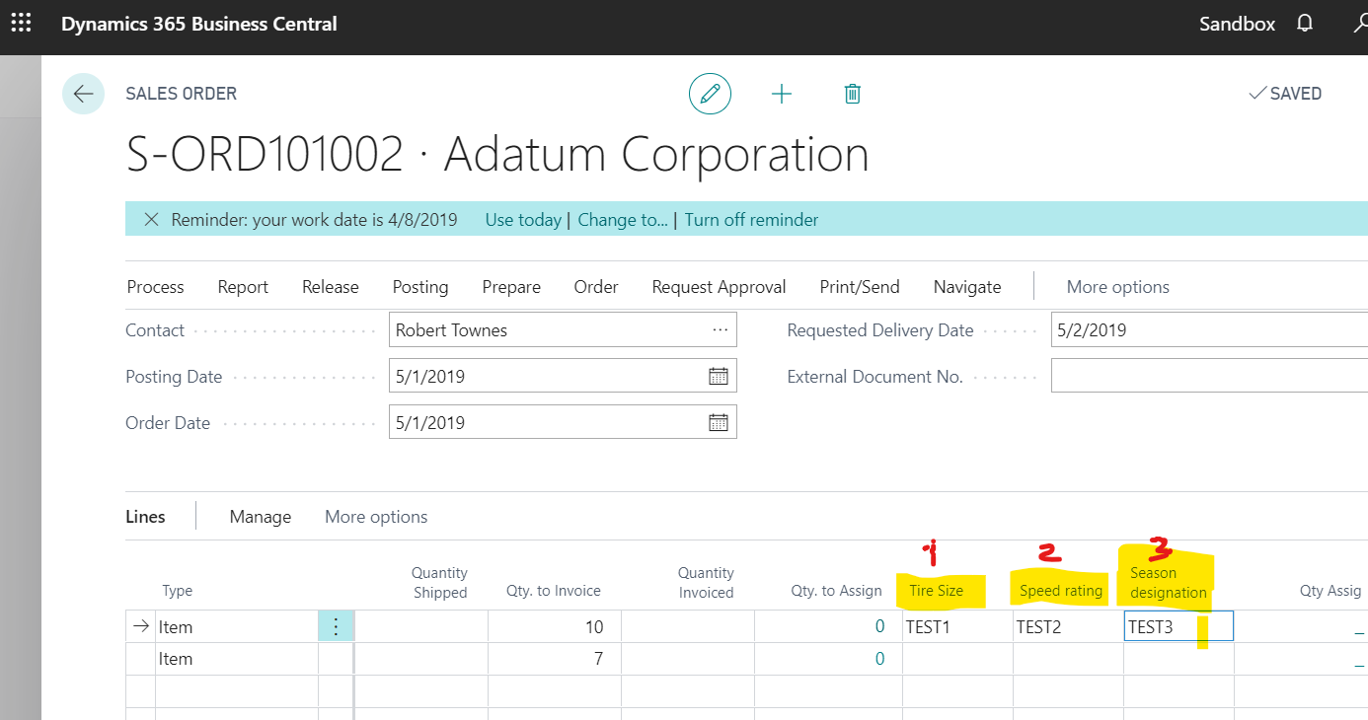

Then post the document, selecting Posting> **Ship and Invoice** Option.

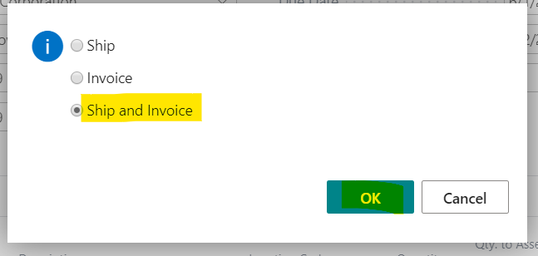

After posting go to the find the posted Sales Invoice.

Go to the posted Sales Invoice lines and scroll right and after right side of Deferral Code, you will find the New 3 fields, which has flowed to posted sales invoice lines from Sales Line.

